Consultant Portal Requirement
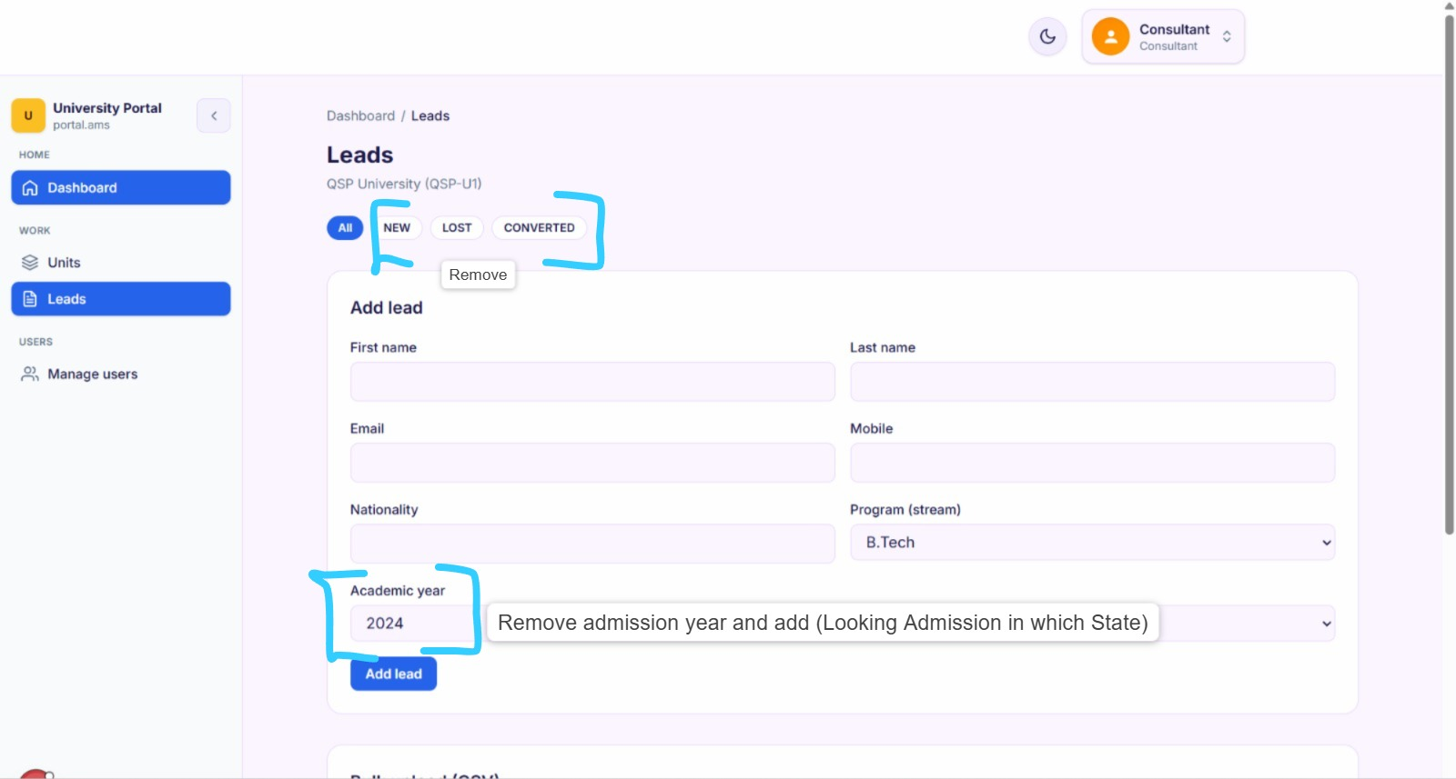
followed by 1 more section of Referral
First Name
Last name
contact
email id
Consultant name it should auto read while creating the lead and sending it to students.
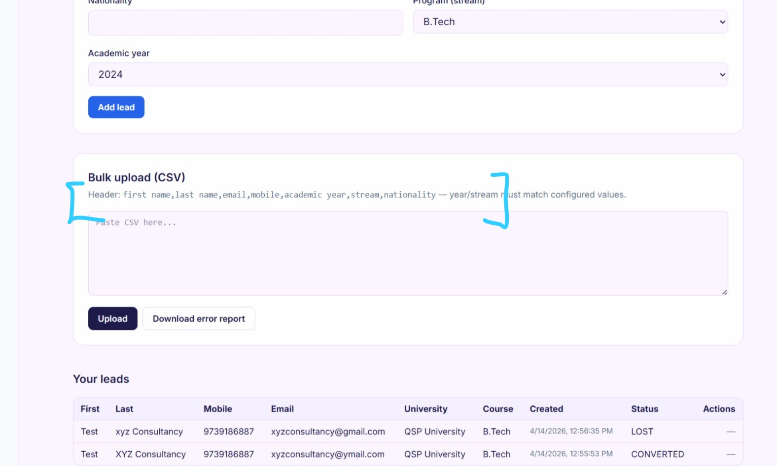
First Name
Last Name
Email
Mobile
Stream
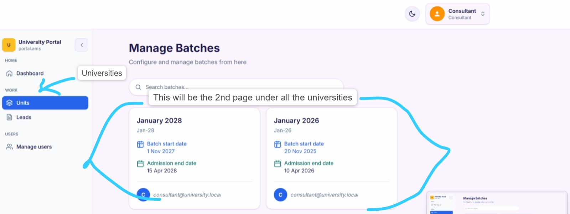

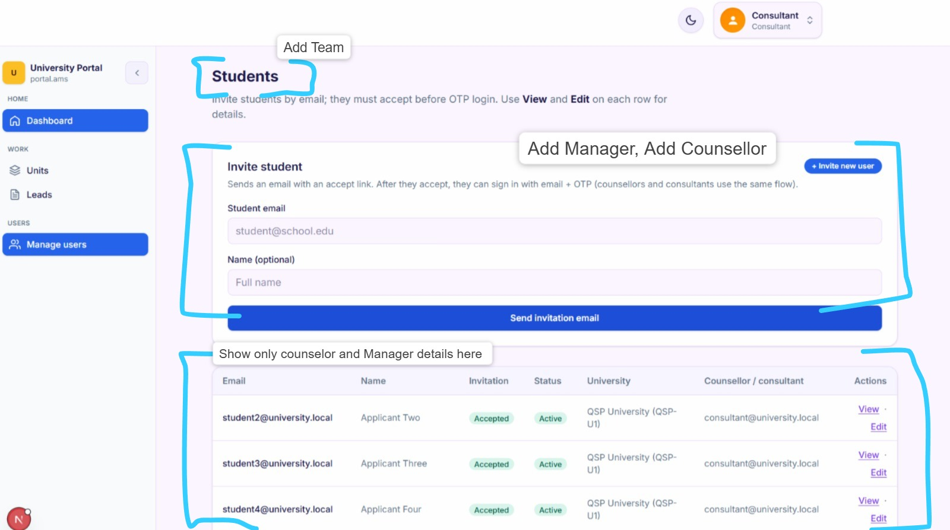

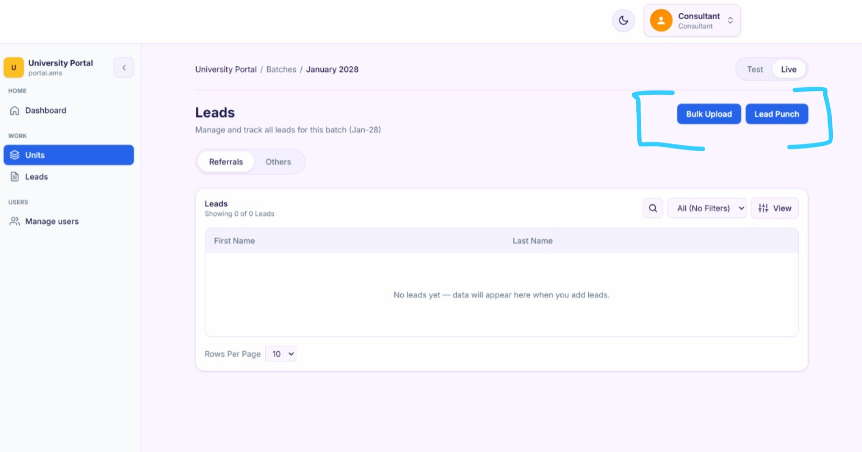
Consultant Portal Access
Remove Leads button from left section
Replace consultant into Admission Partner in the complete Portal

Student Portal Access
I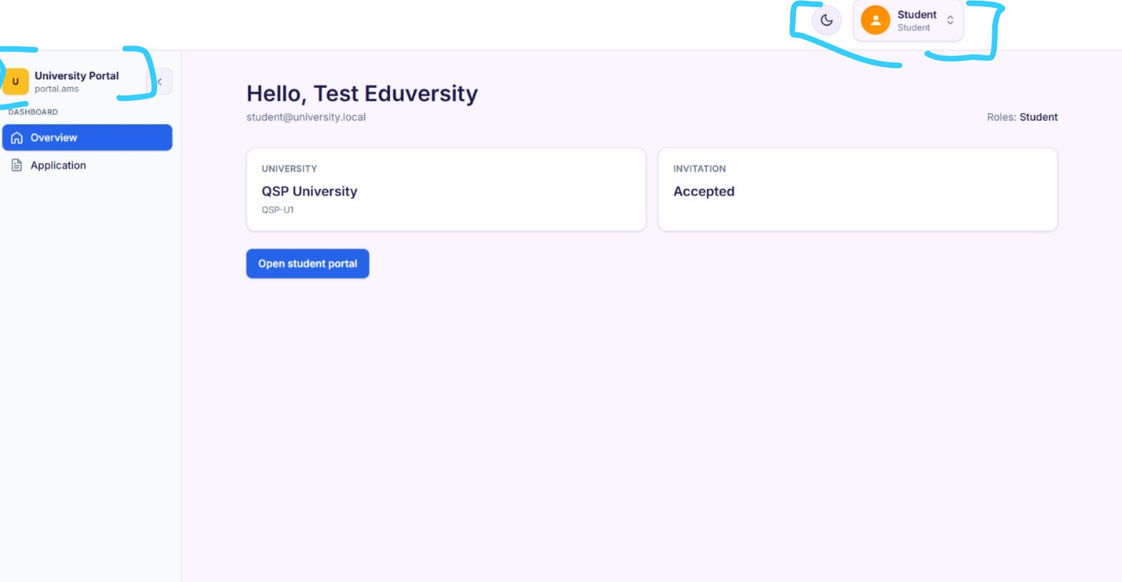
In student portal its showing university portal as a dashboard name.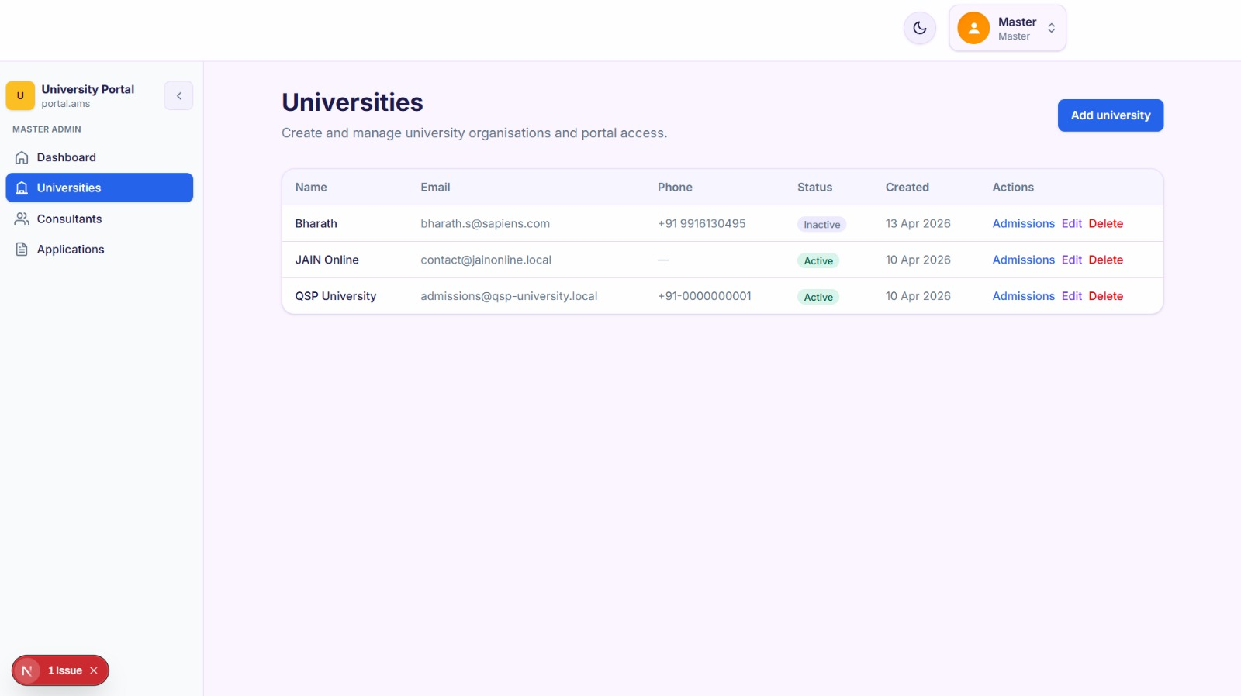
Master Access Portal Requirement
University - After selecting any university admissions should be visible for that particular university with consultant name.
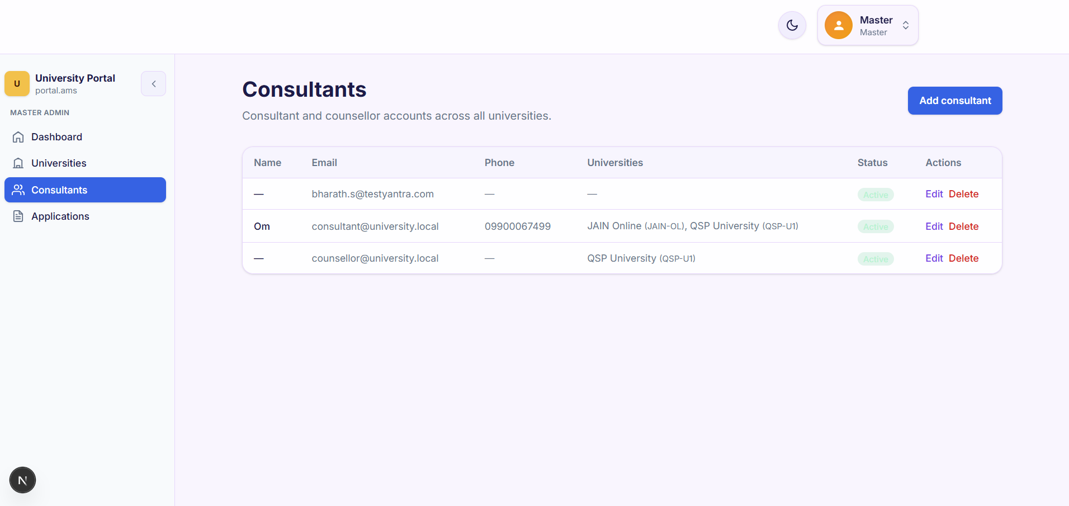
Master Access Portal Requirement
Replace “Consultant” with “Admission Partner”
After selecting any consultant/admission partner admissions should be visible for that particular consultant with university name.
Master Access Portal Requirement
In University Section and Consultant section all the universities & Consultant will come in a block format then after selecting any university/consultant all students details should reflect.

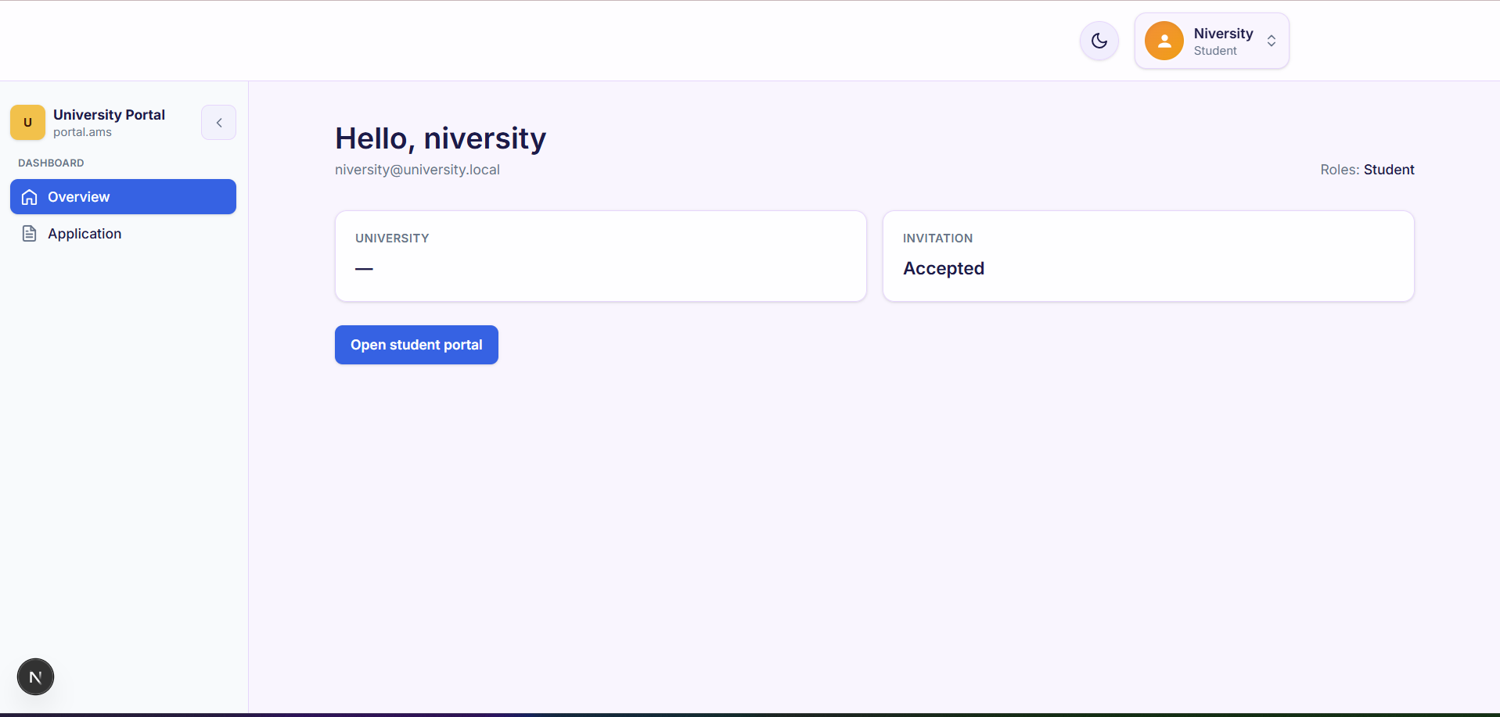
University Portal Requirement
University – This page is perfect in Mobile but in web it looks blank.
University logo we can add in Overview page, Give one section to add the logo of university.
Branch Access Requirement
One more login we need to add for our Qspiders Branches
It will be the replica of Consultant/Admission portal itself , Just while adding the lead in the Admission partner it should autoread the branch name while sending it to student.

